|  |  |  |  |  |  |  |  |  |  |  |  |  |  |  |  |  |  |  |  |  |  |  |  |  |
| --- | --- | --- | --- | --- | --- | --- | --- | --- | --- | --- | --- | --- | --- | --- | --- | --- | --- | --- | --- | --- | --- | --- | --- | --- |
|  |  |  |  |  |  |  |  |  |  |  |  |  |  |  |  |  |  |  |  |  |  |  |  |  |
|  |  |  |  |  |  |  |  |  |  |  |  |  |  |  |  |  |  |  |  |  |  |  |  |  |
|  |  |  |  |  |  |  |  |  |  |  |  |  |  |  |  |  |  |  |  |  |  |  |  |  |
|  |  |  |  |  |  |  |  |  |  |  |  |  |  |  |  |  |  |  |  |  |  |  |  |  |
|  |  |  |  |  |  |  |  |  |  |  |  |  |  |  |  |  |  |  |  |  |  |  |  |  |
|  |  |  |  |  |  |  |  |  |  |  |  |  |  |  |  |  |  |  |  |  |  |  |  |  |
|  |  |  |  |  |  |  |  |  |  |  |  |  |  |  |  |  |  |  |  |  |  |  |  |  |
|  |  |  |  |  |  |  |  |  |  |  |  |  |  |  |  |  |  |  |  |  |  |  |  |  |
|  |  |  |  |  |  |  |  |  |  |  |  |  |  |  |  |  |  |  |  |  |  |  |  |  |
|  |  |  |  |  |  |  |  |  |  |  |  |  |  |  |  |  |  |  |  |  |  |  |  |  |
|  |  |  |  |  |  |  |  |  |  |  |  |  |  |  |  |  |  |  |  |  |  |  |  |  |
|  |  |  |  |  |  |  |  |  |  |  |  |  |  |  |  |  |  |  |  |  |  |  |  |  |
|  |  |  |  |  |  |  |  |  |  |  |  |  |  |  |  |  |  |  |  |  |  |  |  |  |
|  |  |  |  |  |  |  |  |  |  |  |  |  |  |  |  |  |  |  |  |  |  |  |  |  |
|  |  |  |  |  |  |  |  |  |  |  |  |  |  |  |  |  |  |  |  |  |  |  |  |  |
|  |  |  |  |  |  |  |  |  |  |  |  |  |  |  |  |  |  |  |  |  |  |  |  |  |
|  |  |  |  |  |  |  |  |  |  |  |  |  |  |  |  |  |  |  |  |  |  |  |  |  |
|  |  |  |  |  |  |  |  |  |  |  |  |  |  |  |  |  |  |  |  |  |  |  |  |  |
|  |  |  |  |  |  |  |  |  |  |  |  |  |  |  |  |  |  |  |  |  |  |  |  |  |
|  |  |  |  |  |  |  |  |  |  |  |  |  |  |  |  |  |  |  |  |  |  |  |  |  |
|  |  |  |  |  |  |  |  |  |  |  |  |  |  |  |  |  |  |  |  |  |  |  |  |  |
|  |  |  |  |  |  |  |  |  |  |  |  |  |  |  |  |  |  |  |  |  |  |  |  |  |
|  |  |  |  |  |  |  |  |  |  |  |  |  |  |  |  |  |  |  |  |  |  |  |  |  |
|  |  |  |  |  |  |  |  |  |  |  |  |  |  |  |  |  |  |  |  |  |  |  |  |  |
|  |  |  |  |  |  |  |  |  |  |  |  |  |  |  |  |  |  |  |  |  |  |  |  |  |
| Unit table  Total units 256 in case you want to count. ---that’s sweet! | | | | | | | | | | | | | | | | | | | | | | | | |
| |  | | --- | | ___________________________________________’s | | | | | | | | | | | | | country | | | | | | | | | | | | | | |

Symbols:

defensive:

protect the command center “C”

set your center anywhere.

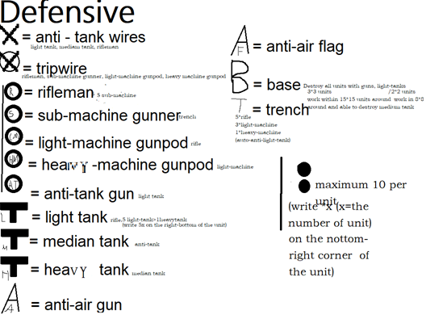

Every unit is $1

You have $200 on the start

Every $15 were earned per day

SHOP:

In here, you can buy units with discounts, it is stored in your storage automatically. You can also trade with others

|  |  |  |  |
| --- | --- | --- | --- |
| 20 rifleman | $17 | 60 tripwire | $50 |
| 3 base 3*3 | $25 | 3 trench | $1 |
| 10submachine | $9 | trade | |

Storge:

The units there placed do not cost money.

|  |
| --- |
| 1 bonus rifleman every day |

This is the server of the game : <https://game-of-war-V1.8p1515.repl.co>

Fold it to write your name on the back and keep it. Please jot down every outcome and income under the unit table

Game of war 1st generation Mchigm liited all wrights reserved